4. Git-HOL
Objectives
- Explain how to resolve the conflict during merge.
In this hands-on lab, you will learn how to:
- Implement conflict resolution when multiple users are updating the trunk (or master) in such a way that it results into a conflict with the branch’s modification.
Prerequisites
The following are the pre-requisites to complete this hands-on lab:
Hands-on ID: “Git-T03-HOL_001”
Implementation:
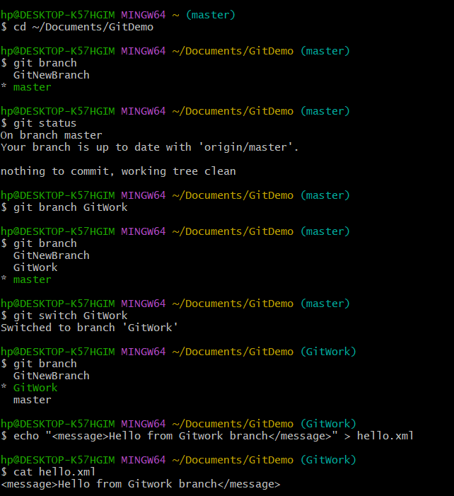
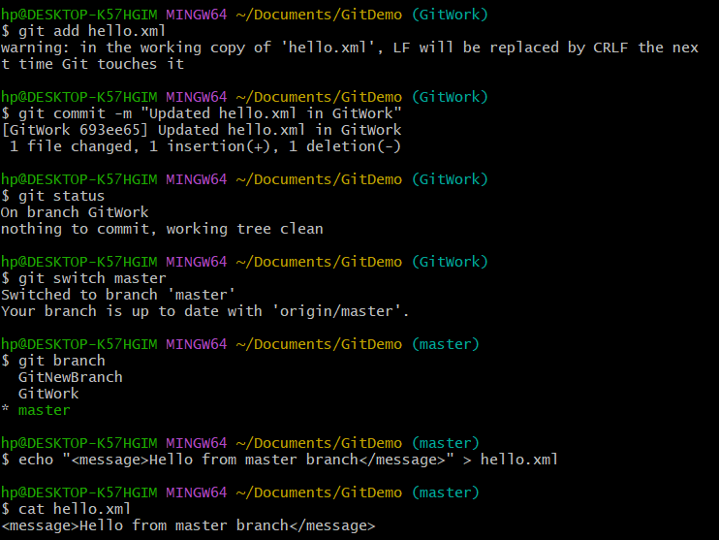
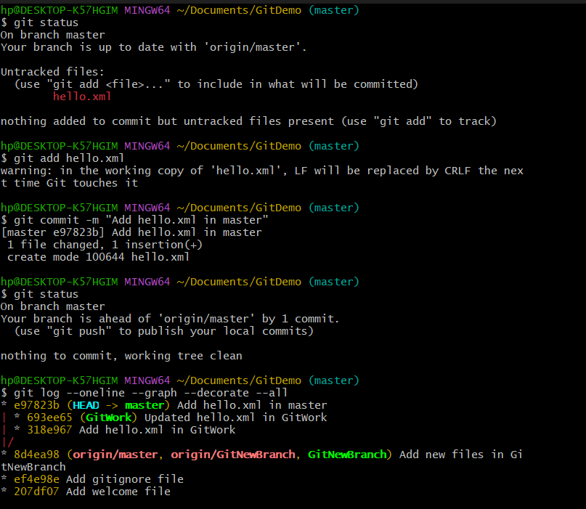
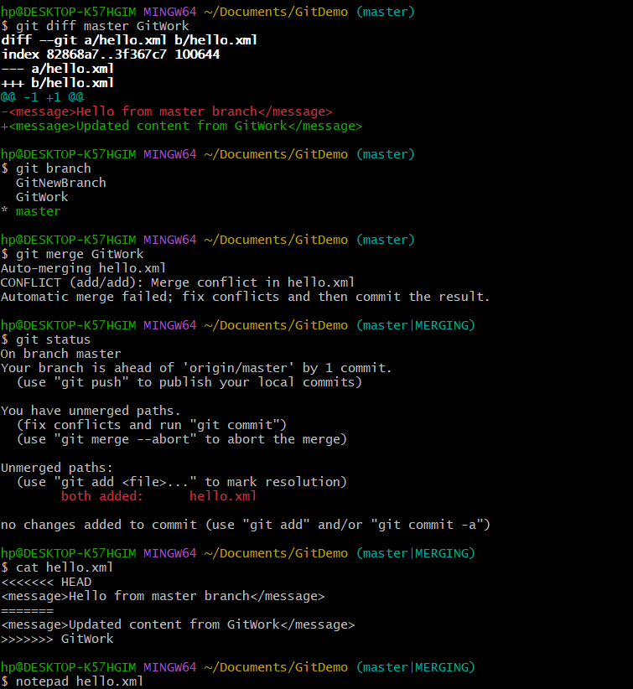

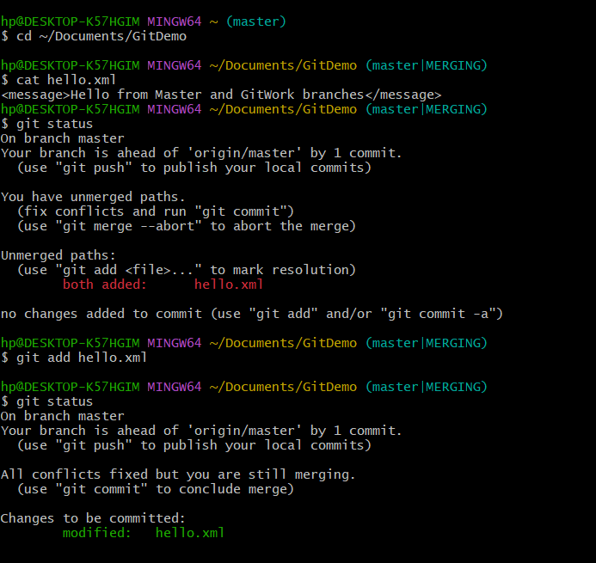
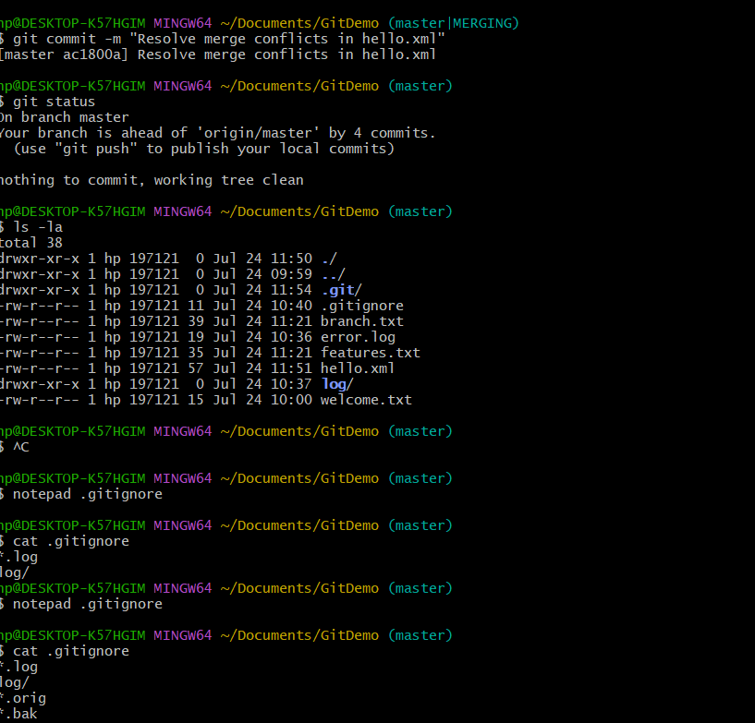
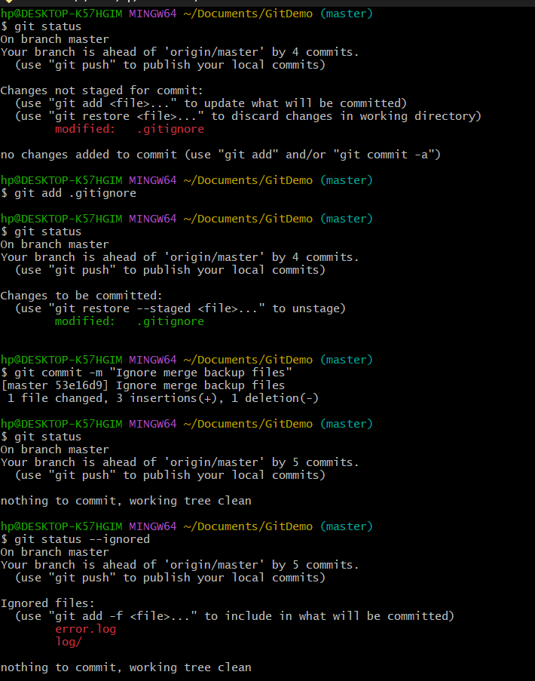

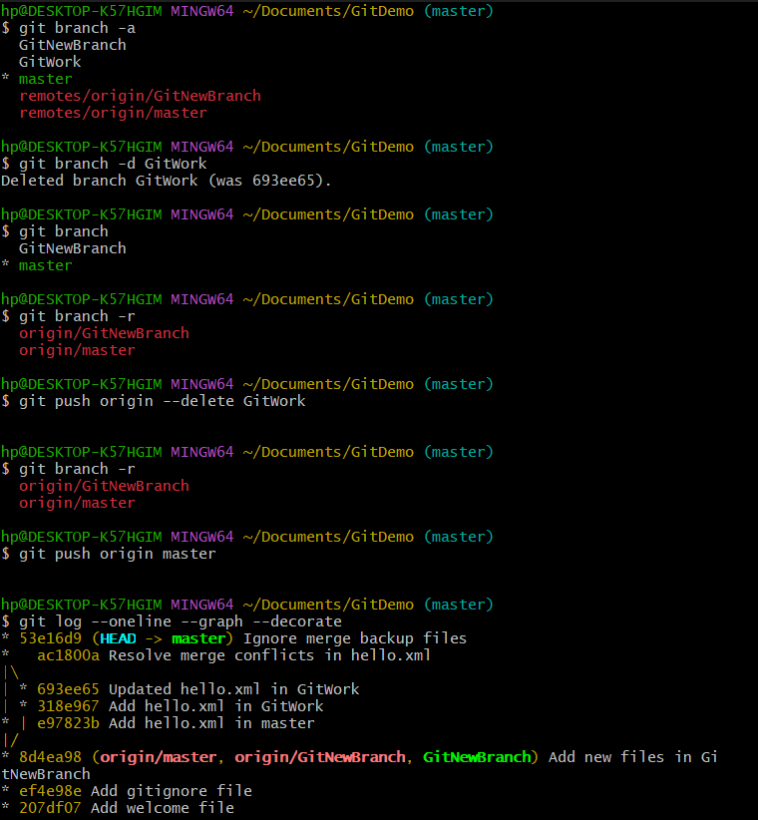

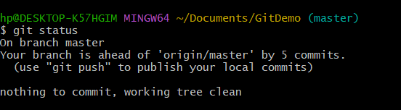

OUTPUT:
